Document 1
ART COMPETITION FOR CATHOLIC SCHOOLS
During the Season of Creation
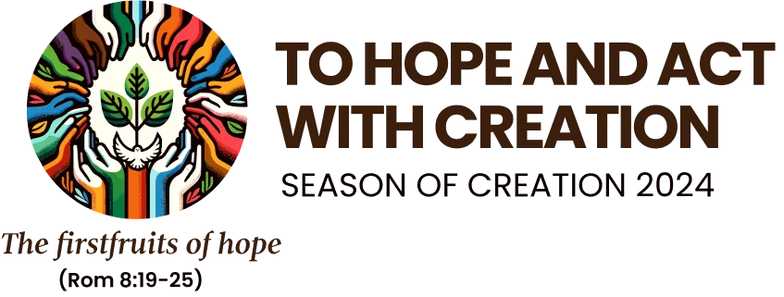
1 September - 4 October 2024

Each year we celebrate the Season of Creation between the 1 September to 4 October. There is theme for each year with this year’s them being To Hope and Act with Creation. The National Religious Education team will sedn out materials to use during the season.

Background:

The encyclical Laudato Si’ On Care for Our Common Home, published by Pope Francis on Pentecost Day in 2015 is the most integrated document of Catholic Social Thought ever to appear. It synthesises up-to-date environmental science, with relevant social studies and politics, theology with spirituality, education with psychology. Written in response to the escalating crisis of environmental degradation, the encyclical outlines an integral theology which recognises the interconnectedness of all created things. The Pope teaches that the only way to alleviate the ecological crisis is a combination of respectful dialogue between everyone on the earth, a values-based ecological education, and spirituality that places God’s gratuity and creation at its centre. This combination of responses will lead to a new lifestyle which will be more respectful of our suffering planet and its limitations.

In Laudato Si’ Pope Francis says that the goal of contemporary environmental education is “to restore the various levels of ecological equilibrium, establishing harmony within ourselves, with others, with nature and other living creatures, and with God.” This requires educators who can help people to grow as ethical “ecological citizens” who have solidarity, responsibility and compassionate care for their environment.

In the 2020 Global Compact on Education, initiated by Pope Francis, Catholic schools, universities, faculties and colleges around the world committed “to watch over and cultivate our common home, protecting it from the plundering of its resources, adopting more sober lifestyles and aspiring to the full use of renewable energies.” Having a school-wide art project during the Season of Creation is an opportunity to bring this commitment to the awareness of the learners and school stakeholders at their respective levels.

The learning outcome of the art project is for each learner to engage his or her imaginative, synthetic faculties to see how our environment features in daily life. Learners work either individually or in groups to create a new communication of the importance yet fragility of the environment, what is going wrong with it, or how we can be involved in its care.

Creating a Catholic School Laudato Si’ Calendar:

During the Season of Creation (1 September – 4 October 2024), Catholic schools around South Africa are invited to produce artwork relating to the environment and to care for our Sister-Mother Earth, our common home.

Learners of every grade will be given time during the school-day in the liturgical season to work on the conception and execution of their artwork. This can be individual or groups.

Schools will choose the most engaging artwork from every grade.

One digital photograph of every chosen artwork (one per grade) will be submitted to the CIE by the participating schools.

Thirteen of these photographs (one from each grade) will be selected for inclusion in a Laudato Si’ perpetual calendar.

At the end of the Season of Creation the schools hold an exhibition of all the artwork that is produced at the school. This exhibition will engage the schools’ stakeholders in reflection about the environment and their relationship with the environment.

Requirements:
Each school will require sufficient art material for the work to be done:
Art paper / card
Wax crayons; poster paint; acrylic paint; permanent markers;
Glue for collages
Natural material
Waste material
Recycled material

Submission of photographs:
The photographs of the artwork will be submitted in JPEG format and a maximum file size of 1.5MB.
Please use landscape format
Please send your photographs to:
ntebeng@cie.org.za
Closing date: end of business, Friday 11 October 2024.
With each photograph, please give: the title of the work
the name of the artist (or artists if it is a group artwork)
the grade of the artist/s
the name of the school

Selection of photographs for the calendar:
Once the schools have all submitted their high-quality photographs of the artwork that they have produced, the CIE will select among the artworks for inclusion in the calendar
There will be one celebrity selector, and two other impartial selectors who are experts in of art, and in environmental care.
Artworks will be selected for inclusion in the calendar based on:
their relevance to the theme of care for our common home
their originality and creativity
their artistic merit.
There will be thirteen selected artworks: one for each month, and one for the front cover.
The selectors’ decision will be final. No correspondence will be entered into.

Printing of calendar:
The calendar will be printed in A3 landscape format, wire-bound at the top, so that the pages are large enough to give a good reproduction of the artwork.
The printing will be done by a professional printer.

Distribution of calendar:
Two free calendars will be given to every school that submitted photographs of the original artwork done by their students.
One copy of the calendar will be sent to Pope Francis.
One copy of the calendar will be sent to every member of the Southern African Catholic Bishops’ Conference.
One copy of the calendar will be given to every learner who has a photograph of his or her work in the calendar.
The schools will be notified which submissions have been included in the calendar.
Schools can order additional calendars at a nominal cost, which they can then (if they desire) sell them with a markup to raise school funds.
Before 15 November 2024 the schools should let CIE know how many calendars they wish to order.

For further information, please contact: Ntebeng Mohapi at CIE: ntebeng@cie.org.za

Laudato Si’ paragraph 210.
See: Global Educational Pact Team, OIEC, UISG-USG, Building Together the Global Compact on Education (Rome: OIEC, 2023), 7.

