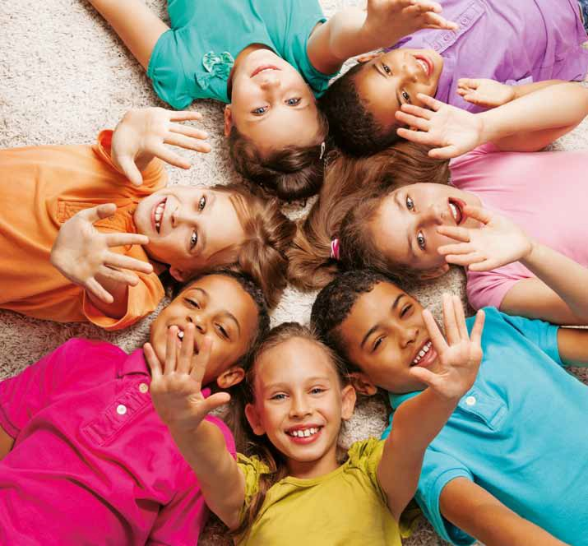

**I CAN!**

**Children and Young people from all over**

**the world meet the Challenge of *laudato si’*: on Care for our Common home**

**T**

**e**

**a**

**c**

**h**

**e**

**r**

**’**

**s**

**G**

**u**

**i**

**d**

**e**

**T**

**e**

**a**

**c**

**h**

**e**

**r**

**’**

**s**

**G**

**u**

**i**

**d**

**Get involved!**

**e**

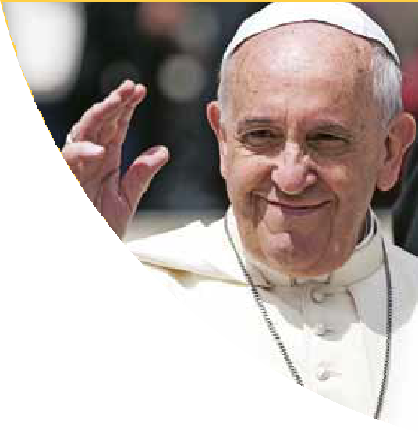

**«The urgent challenge to protect our common home** includes a concern to bring the whole human family together to seek a sustainable and integral development, for we know that things can change… Humanity still has the ability to work together in building

our common home… **Young people demand change.** They wonder how anyone can claim to be building a better future without thinking of the environmental crisis and the sufferings of the excluded».

**(*Laudato si’* 13)**

**education** will be inadequate and ineffectual unless we strive to promote a **new way** of thinking about **human** beings, **life, society** and our **relationship** with **nature.**

With their professionalism and the richness of their humanity they provide, educators are all called to **help young people**

**to become the builders of a more united and peaceful world.**

#### dear

**brothers and sisters**

Pope Francis

I’m certain that children and young people today need a life that brings about hope and seeks the beauty, the truth and the communion with the

others in order to achieve a common growth. **Young people should** therefore **be heard**: it’s the «apostolate of the ear»: **we**

**must listen to children and young people.**

Dear children, dear young people, we can’t live without facing

challenges, without meeting challenges… Please, don’t just observe life from the balcony! Meet the challenges... **You must make noise; you are the seed of change**

**of this society.**

#### «Children and young people need only an opportunity

**to change the world»**

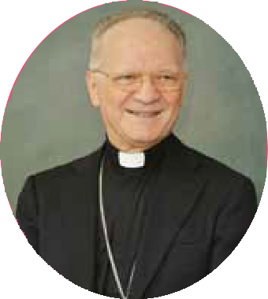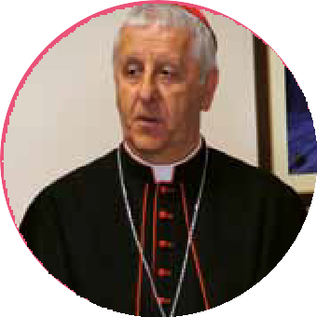

Dear teachers:

It is urgent to humanize the education, focusing on the children and young people, giving them the autonomy and the principal role they need to play so they can grow from within, amid a community which is alive, interdependent, tied to a common fate and which leads us to the fraternal humanism.

In this new scenario, and in order to educating from the capabilities and the uniqueness of each one, adults must step back, they need to say less and to listen more: listen to children and young people. Educating is so much more than teaching. We have to provide the conditions and the space for them to build together a project of change capable to transform their real contexts. Let’s trust them, without any fear… We’ll be amazed.

**Cardinal Giuseppe Versaldi**

Prefect for the Congregation for Catholic Education

Dear children, dear young people:

Open your heart; let yourselves be impacted by the reality, whether near or far, that surrounds you; empathize with the people, with their social and ecological settings; exercise your mind creatively and critically and take action; don’t take into account only what is good for you, but rather think about what good can you do for the others. Trust yourselves!

Therefore, join your heart, your mind and your hands, and take action, by getting committed, cooperating one with another, complementing one another without competing, showing solidarity, co-creating stories of personal, social, and environmental change.

Finally, I invite you to share your stories so they can inspire others, so people realize you can change the world.

**Monsignor Angelo Vincenzo Zani**

Secretary of the Congregation for Catholic Education

Dear children, dear young people:

Open your heart; let yourselves be impacted by the reality, whether near or far, that surrounds you; empathize with the people, with their social and ecological settings; exercise your mind creatively and critically and take action; don’t take into account only what is good for you, but rather think about what good can you do for the others. Trust yourselves!

Therefore, join your heart, your mind and your hands, and take action, by getting committed, cooperating one with another, complementing one another without competing, showing solidarity, co-creating stories of personal, social, and environmental change.

Finally, I invite you to share your stories so they can inspire others, so people realize you can change the world.

**Monsignor Angelo Vincenzo Zani**

Secretary of the Congregation for Catholic Education

**WHAT?**



**Co-creating a project or story of**

**transformation, whose primary focus is**

***laudato si’* and the SdG, capable of meeting the challenges it presents.**

**FOR WHAT?**

**Responding to an urgent appeal… children and young people take on the challenge.**

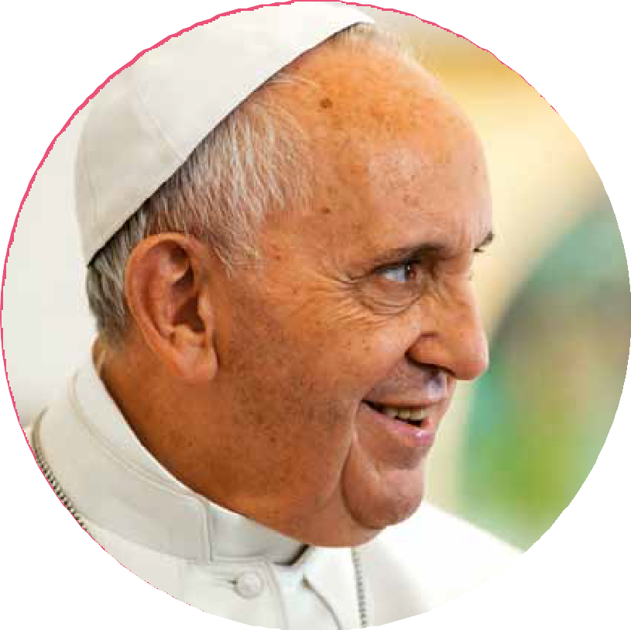

«The human environment and

the natural environment are deteriorating together, and this deterioration of the planet weighs upon the most vulnerable of its people… The urgent call and

challenge to care for creation are an invitation for all of humanity to work towards sustainable

and integral development»

**(Pope Francis and the Ecumenical Patriarch Bartholomew, 2017)**

**Pope Francis also suggests us:**

«There is a nobility in the duty to care for creation

through little daily actions, and it is wonderful how education can bring

about real changes in lifestyle»

**(*Laudato si’* 211).**

On September 1st 2017 in a joint message, Pope Francis and Ecumenical Patriarch Bartholomew «urgently appealed to hear the cry of the earth and to attend to the needs of the marginalized…» and then they added: «there can be no sincere and enduring resolution to the challenge of the ecological crisis and climate change unless the response is concerted and collective, unless the responsibility is shared and accountable, unless we give priority to solidarity and service».

**i can**

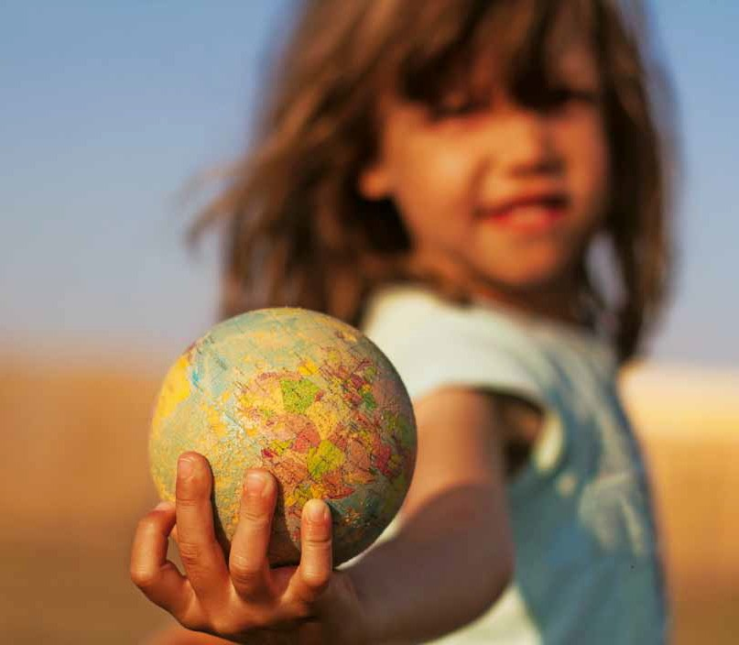

rom the education we wish to respond to these challenges with **responsibility, imagination, cooperation and**

F

**commitment,** from every educational institution, from every classroom, from every training activity, both official and non-official.

We won’t do it without the children and young people; we won’t do it by telling them what to do or what not to do; **we’ll do it**

**by empowering them so they can feel inside what has been harmed, so they can empathize and jointly think of an achievable and attainable solution which they can make possible and share;** they will thus be able to convey and to inspire others to help create a global movement of

change and improvement of the common home and the dignity of the human person, a movement featuring them, who are full of originality and who lack of the damage,

corruption and interests of adults and markets; **they will transform their tangible reality and environment and they will bring about thousands and millions of stories of change.**

For that purpose children in every classroom

of every school, of every district, of every city and country will be offered to name a challenge and to critically, creatively and

cooperatively meet the challenge and work on it by following **the design for Change (dfC) methodology.**

**EDuCATION sHOulD TEACH us THAT WE CAN.**

### What’s Design for Change?

t’s a methodology that came into being in India by **Kiran Bir sethi.** Through this methodology students are empowered

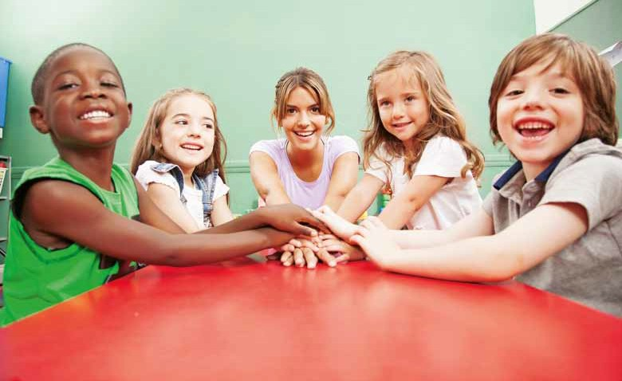

I

so they become proactive and committed to the transformation and improvement of

people and their backgrounds. Children over three years old can identify a problem of their environment or community and reach a solution along with other children.

Every project or story consists of four simple steps that lead them to change their personal, social and environmental reality:

**feel** the needs and problems.

**imagine** new solutions.

**do and make** the change possible.

**share** their story of transformation in order to inspire other children.

By doing so they create a global chain made up of children and young people that change lives and change the world. To that end they put in action **four basic skills:**

* **Critical thinking**
* **Creativity**
* **Cooperation**
* **Communication**

Thus, by getting involved, by putting in action these skills, by following their motto «I can!», everyone is able to change the lives of many people; they create jobs, reduce child labor, restore the forests, recycle waste, save energy, reduce or eradicate bullying at school, avoid marginalization of their classmates, save and de-contaminate water, fight against forced child marriage, create healthy habits, stand up for towns that are less focus on adults…



**METHODOlOGY**

**Stages of each project of change.**

**For groups of 3 to 25 years-old and over**

## Feel



**heart**

**observe, listen, analyze. think from the heart**

**they explore the environment.** (classroom, school, neighborhood, city ...).

**they try to understand.** They discuss and deepen into the focus for action with realism.

They listen at each other. They exercise their empathy.

**they achieve a consensus.** about the problem that they are most concerned and want to solve.

**they involve the community.** Interview the affected to understand and know the real causes.

1. What do you know about your environment?
2. Organizing the information.
3. Locating the focus for action.
4. Choosing a focus.
5. Achieving an understanding.
6. Synthesizing what has been learned.
7. Creating a challenge.

## 2. iMAGine

**mind**

**think about the way to solve the problem Creative and cooperative stage**

**they propose lots of ideas** They want to create a huge impact, which benefits as much people as possible and which creates a durable change.

**they combine and improve ideas**

They cooperate and co-create

**they ground their ideas and propose a prototype**

1. They propose lots of ideas
2. They choose the best ones
3. They make a prototype
4. They implement the proposal
5. They make a work plan

## 4. SHARe 1

**hands and feet**

**take action, they share in their community.**

**they «create ecological citizenship» (*laudato si’* 211)**

**they share with the others**

what they have done.

## 3. do

**hands**

**this is a very exciting stage: they feel more deeply that they can change the world, whether near of far…, and they do it.**

**make a plan**

By making a list with all the activities they are going to make; they document the development of the chosen idea:

What resources will they need? How long will it take them to make the project?

They will distribute tasks and assign responsibilities

**they make their idea real** They build the idea and implement it.

They work as a team and they get advice from their teachers, experts on the issue, or leaders

**they inspire others** with the followed process or the product achieved.

**they disseminate their project** in the classroom, at the school, in the district, city, world.

**they celebrate and share** their satisfaction and achievements.

They gather all the notes, photos, drawings, videos and documents of the project and **make a short video or tell their story of change,** and they upload it to the national or global DFC platform.

1. *Design for Change in Spain and in the countries that use the Spanish model has a fifth step, between Do and Share, named «Evoluate». This step is the moment where they reflect upon what they’ve already done, because the real learning springs from reflection. It is an made-up word which intends to bring together the very essence of this step: they reflect in order to grow, they evaluate what they have lived and they evolve to improve.*



**they think about how did they change** and how their tangible realities change as well

# Guidelines



**StepS tHAt you SHould Follow to MAke pRojeCtS oF**

**CHAnGe witH dFC**

1. **CoMe into ContACt witH tHe leAdeR dFC oF youR CountRy**

You’ll find their details at [**www.dfcworld.com/oiec**](http://www.dfcworld.com/oiec)

If there’s no DFC leader in your country or you can’t contact him, address yourself to DFC global: [**contact@dfcworld.com**](mailto:contact@dfcworld.com)

1. **tHe dFC leAdeR will pRovide you witH:**

Teachers’ training

It’s a key element. DFC methodology requires a new teacher role in the classroom, because he has to facilitate, arbitrate, let the student become the main character, empower him, trust him… That’s why teachers have to be trained for their new role. It can involve additional cost. Financial aid can be obtained.

Booklet to follow the steps of the project. Support and advice.

#### CoMplete youR tRAininG And RAiSe AwAReneSS tHRouGHout tHe populAtion

Reflect and deepen on the methodology. Self-training.

Be ready for your new role in the learning project and for empowering your students.

Set the mood and trust them.

Raise awareness in the school community.

#### MAke tHe dFC pRojeCt, tHe StoRy oF CHAnGe



Follow the four steps:

* 1. Feel
  2. Imagine
  3. Do
  4. Share

Keep an eye on the project, trust, do not interfere.

You can make the project intensively (four or more days a week) or extensively (two to four hours a week).

You can integrate into the curriculum or do it at the end of each term, when the academic content has been finished.

#### SHARe tHe pRojeCt oR tHe StoRy oF CHAnGe

Follow the steps provided and don’t forget to share

Keep an eye on the project and make sure that they are collecting evidence: photos, videos, drawings, testimonies…

Share it and celebrate it in your classroom, at your school, in your education community.

Upload the video or the written story to the DFC web page of your country or the global one.

#### MAke new pRojeCtS

Everything will go magically. Empathy mood will grow.

Everyone (teachers, students, families) will get properly involved, and everyone will play the appropriate role.

#### inSpiRe otHeRS

The other teachers of your group or your school.

Other schools in the area (public, private, catholic, non catholic…)

**Feel, imagine, do, share**

**WITH WHOM?**



**Some other faiths and institutions make similar calls… let’s work together…**

«We need a conversation which includes everyone, since the environmental challenge we are undergoing, and its human

«These statements… echo the reflections of numerous scientists, philosophers, theologians and civic groups, all of which have enriched the Church’s thinking on these questions»

**(*Laudato si’* 7)**

roots, concern and affect us all… We require a new and universal solidarity».

**(*Laudato si’* 14)**

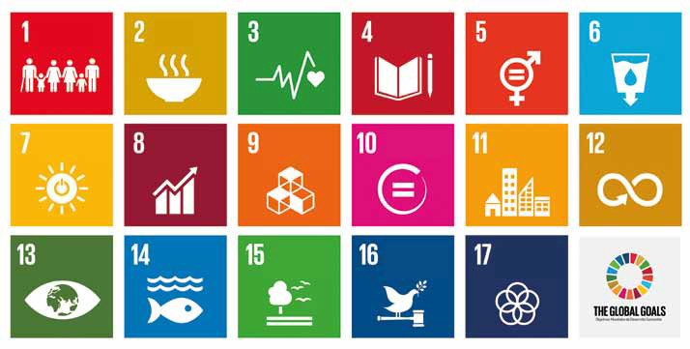

Working on the challenges presented by ***laudato si’*,** children and young people from all over the world commit, in turn,

to achieve **the sustainaBle**

**development goals (sdg) for 2030:**

**no Poverty**

**Zero hunger**

**gooD heaLth anD weLL-being**

**QuaLity eDucation**

**genDer eQuaLity**

**cLean water anD sanitation**

**afforDabLe anD cLean energy**

**Decent work anD economic growth**

**inDustry, innovation anD infrastructure**

**reDuce ineQuaLities**

**sustainabLe cities anD communities**

**resPonsibLe consumPtion anD ProDuction**

**cLimate action**

**Life beLow water**

**Life**

**on LanD**

**Peace, justice anD strong institutions**

**PartnershiPs for the goaLs**



# Chronogram

## A

#### BRoAdCASt And StARt Mid deCeMBeR 2017

From this moment on, project and stories of change can be made and uploaded to DFC platform.

## B

#### iMpleMentAtion oF pRojeCtS oF CHAnGe By CHildRen And younG people FRoM All oveR tHe woRld

From December 2017 to May 2019

## C

#### GloBAl MeetinG in RoMe

November 2019

To share the best stories of change to date

Gathering 8,000-9,000 children and young people so they tell the world what to do for the care of our «common home».

How are they responding to the challenges presented by *Laudato si’*

and the Sustainable Development Goals (SDG)

## d

#### keep MAkinG pRojeCtS oR StoRieS oF CHAnGe

By inspiring many other people, creating a global net of children and young people who change and change their contexts… and who create a more human, fraternal and ecologic world.

**Feel, imagine, do, share**

**wHo inviteS CHildRen And younG people to tAke pARt?**

##### Feel, imagine, do and share projects of personal and ecological and social change

OIEC is committed with the Congregation for the Catholic Education to respond to the challenges presented by *Laudato si’* throughout its network

made up of more than 210,000 schools in more than 100 countries. DFC will help us promote the transformation of people and their environment though education.

The world, our world, needs to change, **and the youngest generations should say it and must do it.** As catholic teachers we must walk along with these young people in their task of building a

common home, a home for peace and international justice, sustainable development and fight against poverty. **dfC is a wonderful tool to do so.**

**Philippe Richard.** Secretary of the OIEC (Catholic International

Education Office)

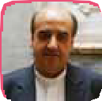The Education Commission of USG and UISG invite to take active part in this Global Project, which, although specific, is full of new synergies that allow us to

reduce the working gap so we can work together and join forces from the different institutions. **the world can be changed, but only from education; education can be changed, but only from teachers; teachers can be changed, but only from the students.** Let’s work together using this methodological tool which encourages the social venture of children and young people. Let’s trust them!

**Pedro Aguado.** Sch. P. President for the International Union

Superior General

**from scholas we would like to invite you dream that changing reality through education is possible,** as many children and young

people are already proving. **the good education**

**starts at home, and our common home is asking us to look after it urgently and**

**responsibly.** This is the commitment that Pope Francis undertook as leader of peace and encounter. Twenty years ago we started together a little experience in Buenos Aires with young Jews, Muslims and Christians, and thanks to your enthusiasm it was spread to the entire world.

Thanks also to the trust that parents and educators have placed in us, this dream has become true. **let’s make an agreement on education to care for our common home!**

**José María del Corral.** President of Scholas Occurrentes

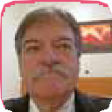**omaeC is joining this global initiative because we trust the new generations and their potential** to create a fairer, more human, more

fraternal world, committed to the care of the

«common home». Our motto predisposes us to cooperate with education. «We enter to learn, we go out to serve». **that’s why we engage to give our voluntary** assistance to serve education, with availability, experience, wisdom, resources and generosity.

**José Antonio Cecilia.** President of the OMAECC, World Organization of Former Students of Catholic Education.

Design for Change offers the world a magical formula to ensure that every child o young person releases their superpower: **«i can!»**. We call this

**magical formula** FIDS (feel, imagine, do, share). When it is used, children and young people undertake some of the greatest challenges of our world and offer simple and innovative solutions. They tell the world that they don’t need to be rich, or strong or over 18 to make changes. **they are already doing it, regardless of their age.** We invite you and your students to use this methodology and to help create a world where every child and young person knows that he/she can!

**Kiran Bir Sethi.** Founder of Design for Change

**INFORMATION AND CONsulTATION**

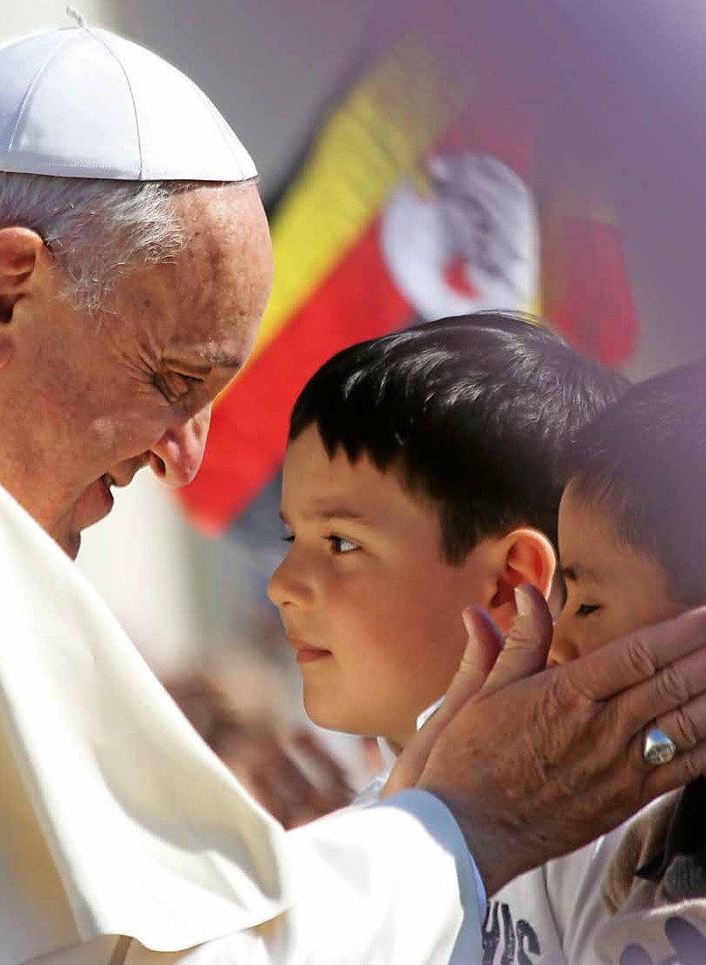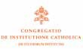

Regarding the Project:

H. Juan Antonio Ojeda, Responsible for Educational Affairs at Catholic International Education Office (OIEC) [ja.ojeda@lasallecampus.es](mailto:ja.ojeda@lasallecampus.es)

Regarding the DFC Methodology:

[www.dfcworld.com](http://www.dfcworld.com/)

Contact: [contact@dfcworld.com](mailto:contact@dfcworld.com)

**e G**

**enT uí**

**c a**

**o d**

**d o**

**a c**

**e**

**íuG Tn**

**e**

**WITH THE BlEssING OF**

**IN COOpERATION WITH**