Dear Principals, Teachers, RE Coordinators and Art Teachers,

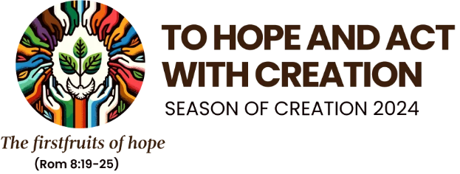

Each year in an endeavour to highlight and conscientise all about climate change and the need for everyone to start making a difference, the international *Season of Creation* takes place. The season starts on the 1st September and ends on the Feast of St Francis of Assisi on 4th October.

This year we have decided to hold an art competition. The details of this are outlined in the attached document (Document 1). Please encourage your learners to take part. It provides an opportunity for a variety of activities to highlight the importance of caring for our Mother Earth. It can also be the beginning of a school’s ongoing environmental project.

There are two possible ways to follow up on the *Season of Creation*. One called *I Can* outlines how to engage learners in a school-based project. See attached outline (Document 2).

The other exciting follow up to the *Season of Creation* could be joining *Planet Fraternity*, a project of the International Office of Catholic Education (OIEC). This project aims to connect Catholic schools across the world with learners developing projects and sharing these together in order to build a Global Village of Education in keeping with Pope Francis’ *Global Compact on Education.* Details of these can be found at [Home - Planet Fraternity Home - Planet Fraternity](https://app.planetfraternity.com/) and [Global Compact on Education | Global Compact on Education (educationglobalcompact.org)](https://www.educationglobalcompact.org/en/)

We have included a simple resource on climate events here in South Africa (Document 3). Much more is available online.

We are aware that some schools have good environmental programmes and we would love to hear about these. We hope that this Season of Creation enables schools to educate and develop knowledge and actions to protect our planet.

We look forward to the Art entries and will keep you informed.

Yours in developing a better world,

The National Religious Education Team

30 July 2024

Documents included:

1 Introductory letter

2. Outline of Art Competition

3. I Can booklet